**A CHATBOT WHICH PREDICTS THE FUTURE PRICE OF THE STOCK**

There are majorly 2 types of chatbots:

-Chatbots used for entertainment

-Chatbots used for business

We are here building a chatbot for business. Chatbots for business are often transactional, and they have a specific purpose. Conversation is typically focused on user’s needs. Travel chatbot is providing an information about flights, hotels, and tours and helps to find the best package according to user’s criteria. Google Assistant readily provides information requested by the user. Uber bot takes a ride request.

And our chatbot is designed for a stock company so that they can predict their approximate stock price on the subsequent days.

We use some formulaes for it based on the company`s data and fetch the result.

**TOOLS USED**

**-ORACLE 11G EXPRESS EDITION**

**-JDK 1.7**

**-ECLIPSE IDE**

**ORACLE DATABASE**

It is a relational database management system from the oracle corporation. We are using it as a database server to store:

-Company`s name

-Company`s domain

-Previous day`s share price(Static that is manually entered by user)

-Selling Price

-Profit

-Number of shares sold

-Share price

**ECLIPSE IDE FOR JAVA**

We are writing our java code in eclipse environment.

It will contain the code for the chatbot which includes java dictionary of commands which will be given to chatbot.

It will have the code for the database connectivity with oracle database.

It will have formulaes for predicting the next day stock price.

The output GUI is made possible by using SWT that is Standard Widget Toolkit.

**FLOW DIAGRAM:**

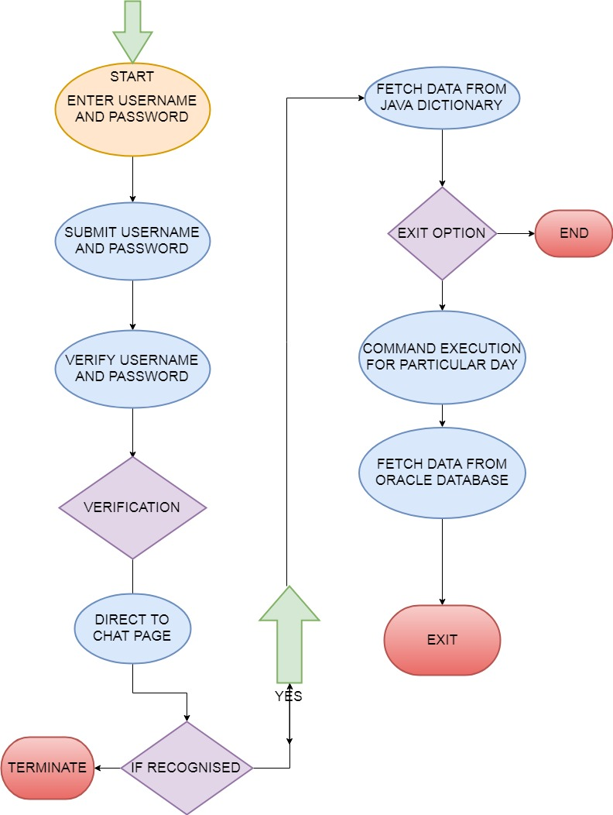

No

**FUNCTIONAL REQUIREMENTS**

The bot should respond to all the inputs it receives.

The bot should be able to send data in the form of text.

The bot should be able to query the data from the database we are using.

The bot should terminate when the user exits and does not create an infinite loop.

**NON-FUNCTIONAL REQUIREMENTS**

The bot should reply as fast as possible to the user commands.

The user have to authenticate themselves that is login with a secure password before asking the queries to the bot.